Counter-Advertising:
Can You Handle the Truth?

Thank-you for joining us for today’s training. This handout is designed to support this workshop and will be referenced during the training. The contents of this handout represent the original and proprietary work product of Dover Y2Y. Participants in this training are welcome to utilize these materials within their own organizations for non-profit, drug prevention purposes.

Dover Youth to Youth provides a wide variety of technical assistance, support materials, and customized training services. More info on page 8. Our contact info is below or check out our booth (#211) in the exhibit hall.
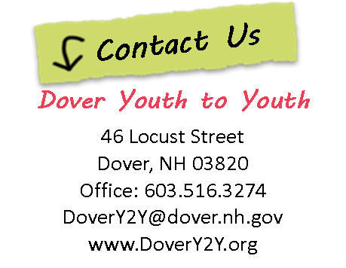
Visit us in the Exhibit Hall
Booth # 211
For more FREE Radio PSA & skit scripts


Contact Us
Contact Us
Dana Mitchell
46 Locust Street
Dover, NH 03820
Office: 603.516.3274
Cell: 603.817.9773
d.mitchell@dover.nh.gov
Dana Mitchell
46 Locust Street
Dover, NH 03820
Office: 603.516.3274
Cell: 603.817.9773
d.mitchell@dover.nh.gov

One Voice Model of
Youth Empowerment
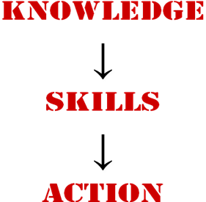
SUMMARY
Counter-Advertising
Approaches

- Attempt to limit the advertising, or eliminate the objectionable content within the ads, in order to prevent/reduce exposure. Generally an environmental or policy change approach.

- Attempt to minimize the impact (effectiveness) of alcohol advertising by exposing their techniques or undercutting their message - often through media initiatives. Often a media literacy approach using these messages below:

Four common Counter-Advertising Messages. These messages take the industry and its advertisers to task for:

- Industry use of misleading, deceptive or untruthful advertising.

- Failure to warn about the risks & consequences of using their product.

- More interest in making $$$$ than the actual consequences on us of using their product.

- Targeting kids & teens as customers and/or using images and messages that are highly attractive to teens.
Page 2
DOVER YOUTH TO YOUTH
PRESENTS

THE ANNUAL
ALCOHOL LOGO LAMPOON CONTEST

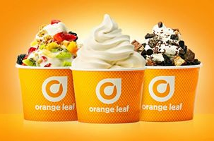
Dover Youth to Youth will be conducting the Alcohol Logo Lampoon Contest open to Dover Middle School students that are in 7th grade. Only one entry per student will be allowed. The student entries should be designed to educate others about the deceptiveness of alcohol advertising. Two students may work together (and share a prize if they win).

Contest Instructions: LOGO LAMPOON - Create an example that mocks (makes fun of) a real alcohol company logo or advertisement, by focusing on how alcohol would be advertised if they were telling the TRUTH about the consequences of using it. For example, Budweiser might become Deadweiser if you wanted to focus on alcohol poisoning. See the reverse side of this form for additional info on the real consequences of alcohol to be used in your ad or logo. Use one or more of these consequences in your art.
Sponsored by
Dover Orange Leaf

Your Logo Lampoon can be done for any type of beer, wine or alcohol product.

The entries will be judged on the following criteria:
- Highlights deceptiveness of alcohol advertising (30%).
- Creativity, imagination, or humor used in the entry (30%).
- Contains information about consequences of underage drinking (20%).
- Neatness, presentation, and overall appearance (20%).

Awards & Prizes:
- Top 30 finalists will be invited to an after school party and receive a prize.
- $50 to the top overall entry of an Alcohol Logo Lampoon in 7th grade
- $25 gift certificate to the top 5 runners-up in 7th grade.

Completed Entries: Must be submitted by Wednesday March 11th to your health teacher. The 30 finalists will be invited to a special event after school on March 25th. The winners will be announced and given their prizes at the event. Make sure your name, grade and email is on your entry to be considered for the awards.

Questions: Can be referred to your health teacher or DARE Officer Dana Mitchell at 516-3274 or d.mitchell@dover.nh.gov

NOTE: All submissions become the property of Dover Youth to Youth and may be used for a poster or T-shirt design – or placed on our web site.
Logo Lampoon background info: Here are some of the things that the adults that make beer and liquor don’t want to talk about when they advertise. Use one or more of these consequences in your artwork:

ADDICTION:
Kids who drink are 4 times more likely to become problem drinkers as adults.
There are 14 million alcoholics (people addicted to alcohol) in the U.S., but the alcohol industry never says “Be careful – our beer is addictive” in its commercials.

FALLS & ACCIDENTS:
Alcohol messes with the brain and causes loss of: balance, reflexes, coordination and depth perception. TV commercials often depict football players, race car drivers, surfers, and other sports that require reflexes and balance. In reality, people who have been drinking too much frequently fall or have other accidents.

VIOLENCE:
Alcohol also affects the part of your brain that controls your impulses - that holds you back from making a quick, stupid decision. People who have been drinking are more likely to get into an argument, get into a fight, or take a swing at someone they are mad at. Some people who have been drinking become more violent or sexually aggressive. In addition, it is easier for people to take advantage of you if you are drinking, but the people who make alcohol don’t like to talk about that.

DECISION MAKING:
Alcohol messes up the part of the brain that you use to make judgments (your ability to tell the difference between good and bad choices), people who are drinking do dangerous or stupid things that they would not normally choose to do.

ALCOHOL POISONING:
You can drink so much that you can shut off the part of the brain that controls breathing and tells your heart to automatically beat – causing you to die. The alcohol industry doesn’t advertise this danger.

HIGHER RISK for DEPRESSION: Some people drink alcohol because they are sad. Alcohol is a chemical depressant that acts on the brain to make depression and other problems worse. Alcohol commercials like to make drinking look fun and care-free, but for some people – it is making things much worse. But they don’t tell you that in the ads.

REDUCED LEARNING POTENTIAL for UNDERAGE DRINKERS:
The brains of younger drinkers, under age 22, are damaged because the brain is still developing until about that age. A substance like alcohol does more damage to an organ that is still developing. Drinking is worse for a teens’ brain for this reason and can reduce learning ability by as much as 10% - which might be the difference between passing and failing.
Community Awareness Initiatives: Gear Exchange

Project Description: The Gear Exchange is an event that is an opportunity for community members to turn in any clothing, athletic gear, or other promotional items that advertise alcohol products (or tobacco, or promote the use of other drugs) in exchange for a piece of our gear that has a positive drug-free message.

Implementation:
Step 1: Set a date, time and location. We hold our event in early April or end of March each year, but you could hold it in conjunction with any event such as Alcohol Awareness month, Red Ribbon Week, or DARE graduation.
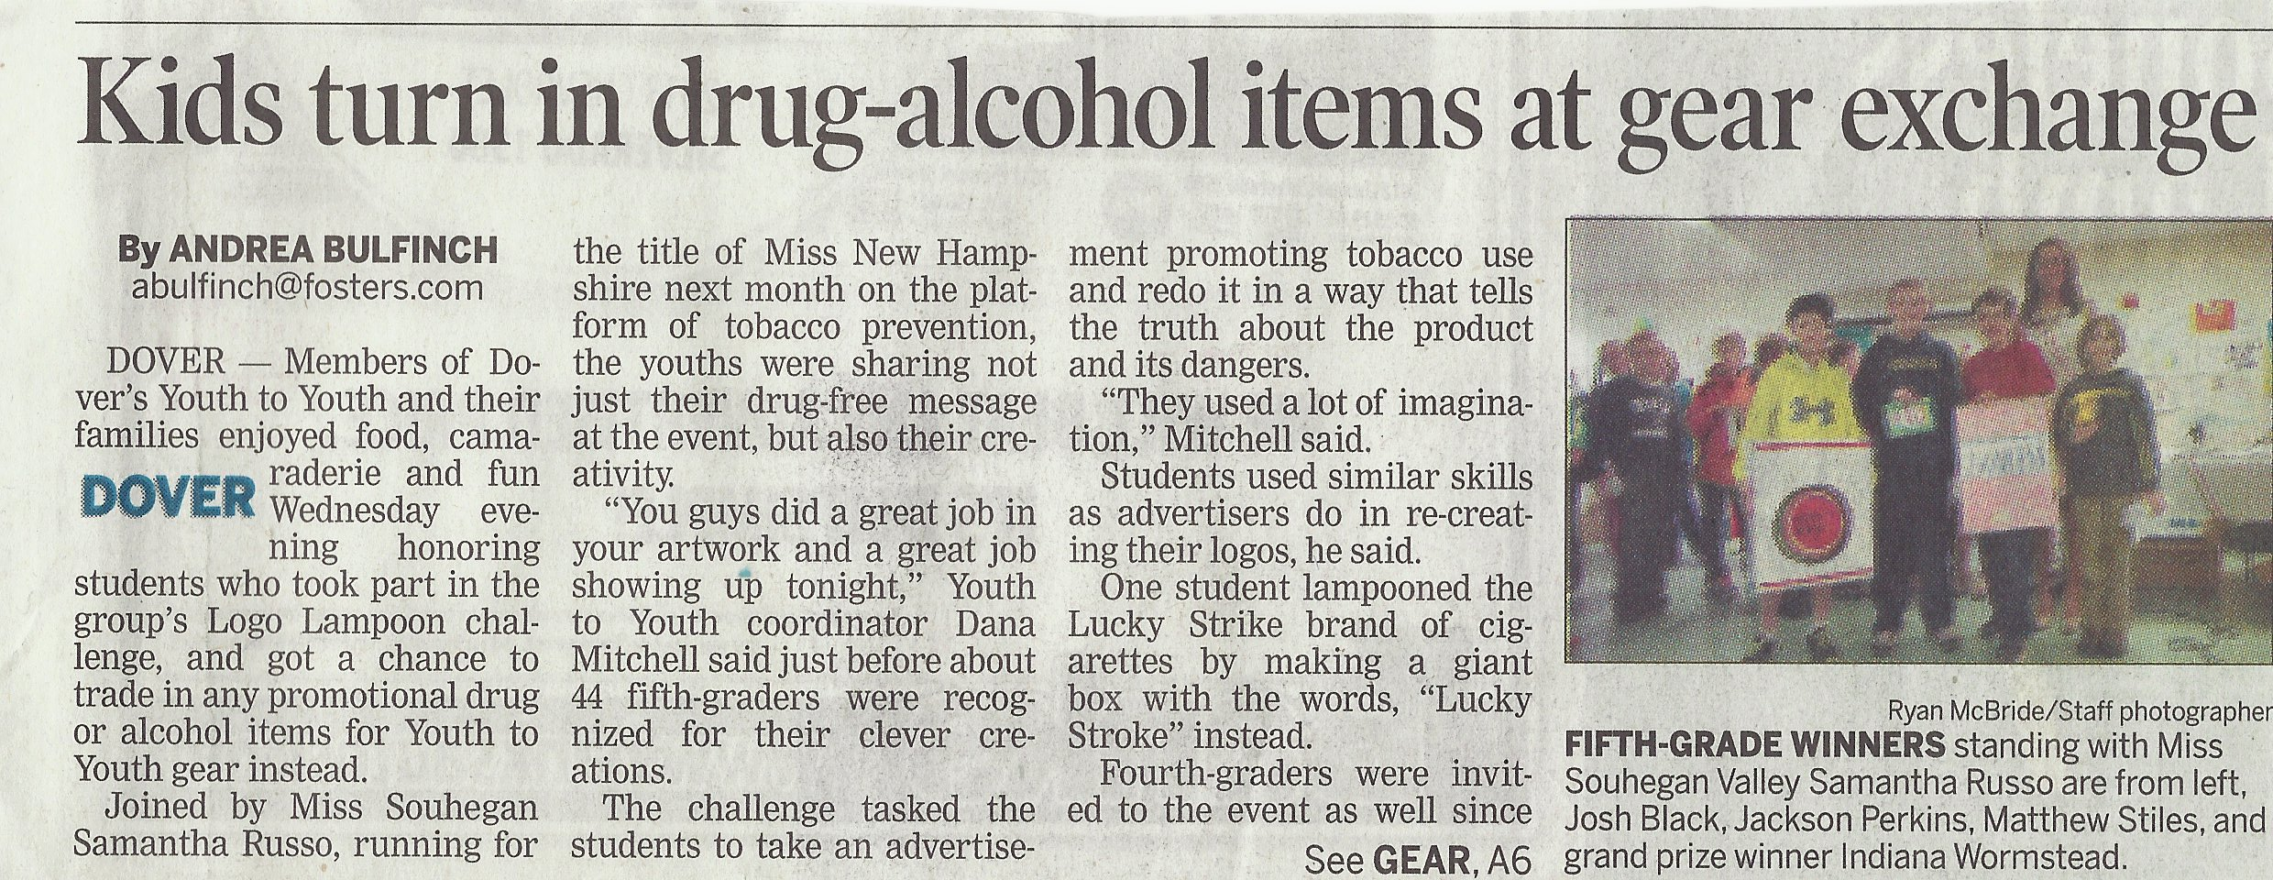
We generally don’t hold it as a stand-alone activity, although a group could do so. We prefer it as an element of a larger evening event that might include handing out the awards to the alcohol or tobacco Logo Lampoon art contest winners. In selecting a location, consider using a place that is easy to find, well known, and provides sufficient parking.
Step 2: Advertise your event. Promote the event in schools with flyers and school announcements. You should also let the larger community know through local newspapers and radio stations. Use of a written press release is recommended and a sample press release is included on the flash drive as well. When advertising your event, make it clear as to when and where the event is along with the type of items that you will be collecting.
Step 3: Collect or design gear that you will give away in exchange for gear that promotes drug use. We like to have a variety of items including t-shirts, Frisbees, water bottles, sports equipment, mugs or posters - so that people can pick something that they like.
You can also do other things to reward people that bring something in for the exchange. We have had an Ice Cream Sundae Buffet at our event where each person bringing in an item receives a ticket so they can go through the buffet. Additional family members can pay to go through.
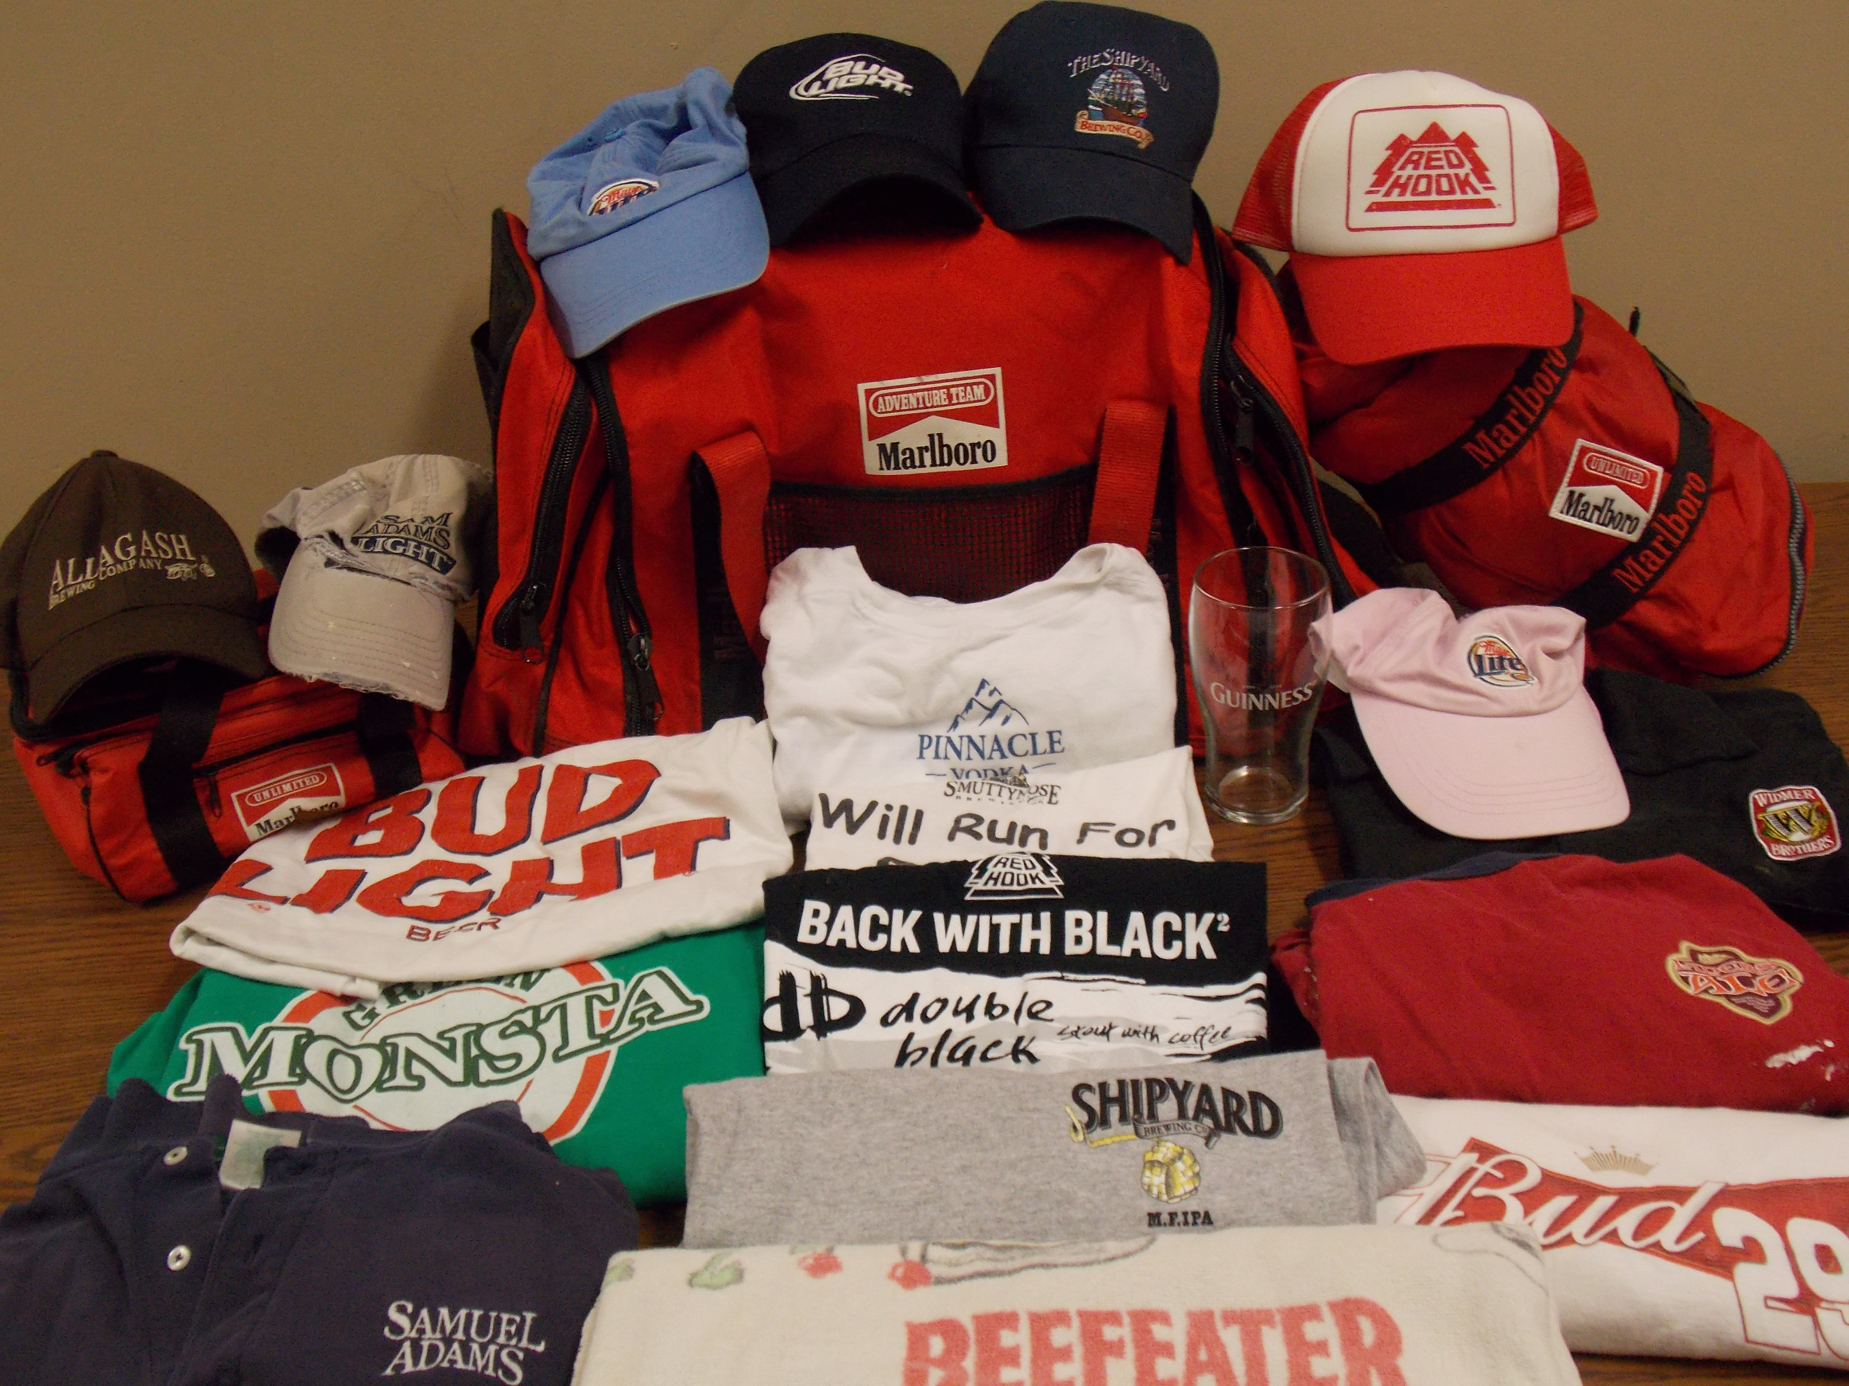
Step 4: Spice up the event. For example, decorate the area with posters or banners or perhaps plan entertainment for the event. In the past we have had local radio stations DJ at the Gear Exchange and had a karaoke contest.
Step 5: Conduct the Gear Exchange.
- Make sure that news media outlets have been invited.
- Plan for sufficient staffing for your activities. Someone should greet people as they enter the building or room and others should staff the table and make the exchanges.
- Don't forget to put up signs directing people to the exchange area if you are in a large building.

Step 6: Wrap Up: At the conclusion of the event, we take a photo of a display of the items collected. Go through all of the items you have received and save ones you might use for a presentation of some type. We rip or damage – and then throw – away gear we won’t keep for our training purposes.
15 Words

TITLE: 15 words CREATED BY: Dover Youth to Youth
DATE: October 2006 FORMAT: Radio PSA
TARGET: Teens STRATEGY : Counteradvertising

SFX: (Music fades out…)
ANCHOR 1: Hello folks! Your listening to radio station WY2Y.

ANCHOR 2: And now it’s time for our question of the day…

ANCH 1: … you can win $10,000 if you are the first caller to answer today’s question correctly.

ANCHR: 2 What do the following words have in common?

Voice 2: Date Rape
Voice 3: Falls
Voice 4: Violence
Voice 5: Liver Disease
Voice 6: Accidents
Voice 7: Unwanted Pregnancy
Voice 8: Depression
Voice 9: Alcohol Poisoning
Voice 10: Suicide
Voice 11: STD’s
Voice 12: and Addiction

ANCHOR 1: Well – I guess the time is up and no one has answered today’s question correctly. Joe, please tell us what the answer is?

ANCHOR 2: They are all words that you have never heard in a beer or alcohol commercial.

ANCHOR 1: Really???? Why wouldn’t they warn us of those risks?

NARR 1: The Beer and alcohol companies spend billions of dollars a year on TV and other advertising… but have you ever heard them use the word addiction – or any of these other words?

NARR 2: We’re warning you about the consequences of alcohol abuse because the alcohol industry refuses to. They’re probably, well, just too busy counting their money.

TAG: Created and presented by Dover Youth to Youth
SKIT TITLE: INTERVIEW (alcohol version)
Interviewer #1: Martha? please send in the next candidate.
[Saddam enters from side... as he walks toward seat...]
#2 Have a seat... Thank you for coming in for this job interview as the Chief Executive Officer of the American Brewing Company.
#1 The interview board would like to ask you a few questions to help us consider you for this position.
#3 Let's start off by having you tell us your name and a little bit about why you want this job.
SH: Well... my name is Saddam Hussein... in my last position I ran a large organization in the Middle East, and I feel it is time for a change.
#4: Mr. Hussein...Why do you think you're qualified to run our alcohol beverage operation.
SH: I think I have most of the qualities you are looking for. I could be called a strong leader with a firm hand... and I have no conscience whatsoever.
#3: Very good ... As a leader do you value organizational honesty and integrity?
SH: Oh no... not at all. In my prior position I became quite skilled at deceit, trickery, deception and lies...
#2: Very impressive ... as you may know... alcohol use can result in falls, accidents, sexual assaults, fights, depression, drunk driving charges, addiction, and even death due to alcohol poisoning. Do you have any experience with deadly chemicals?
SH: Oh certainly... I have experience with a variety of weapons of mass destruction including chemical, biological and some nuclear as well... and I'm not afraid to use any or all of them. In 1988 I even gassed the Kurds!
#1: Well Mr. Hussein...you may be just the guy we have been looking for... when could you start?
SH: I have some legal technicalities that I hope I can resolve quite soon...could be available on very short notice.
#1: Thank you Mr. Hussein... we may be in touch.

Dover Youth to Youth provides a wide variety of technical assistance, support materials, and customized training services. These include:
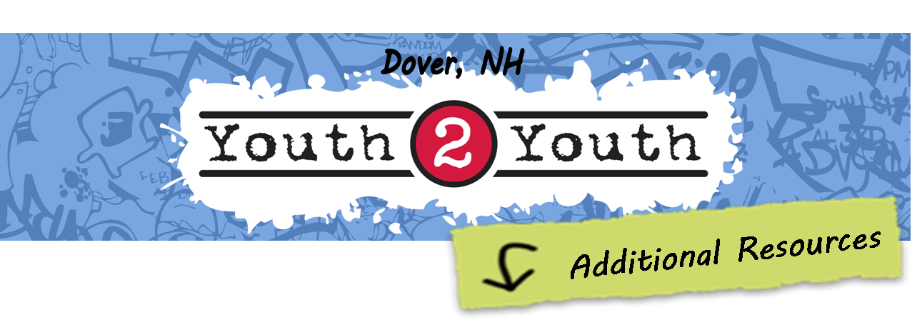

Youth Empowerment Toolkit: A binder containing dozens of Modules, where each Module provides complete instructions and support needed to either provide training on a variety of advocacy skills or to conduct specific programmatic activities. The Toolkit includes a flash drive with 10 gig of support materials needed to implement the Modules, including: lesson plans, PowerPoint, handouts, exercises, press releases, forms, project flyers, skit & PSA scripts that can be re-recorded, and other work product to speed replication of the activities in the Modules.

Youth Advocacy Training: Our students provide on-site and/or webinar-format advocacy training in Media Development, Presentation Skills, Working with the Press, Community Activism, Tobacco Prevention, Media Literacy, Pop Culture Influences on Alcohol Use, and many other topics. This includes training provided at regional or national conferences and training provided to specific youth advocacy programs locally.

Other Resources: Include flash drives containing all of our radio PSA scripts and mp3 files; our theatrical scripts; the Samantha Skunk Rx & Medicine Safety program; and other materials listed on our web site.

Free Materials to Download: Workshop attendees are invited to go to this link: http://dovery2y.org/cadca-presentation/ to download the following materials utilized during the training or in this handout:
- Electronic copies of the PowerPoint and handout
- Mp3 audio files of radio PSAs used in the training
- Sample logo lampoon and gear exchange flyers and programmatic materials.
- Other related materials.

